#5 NN & Gradient Descent

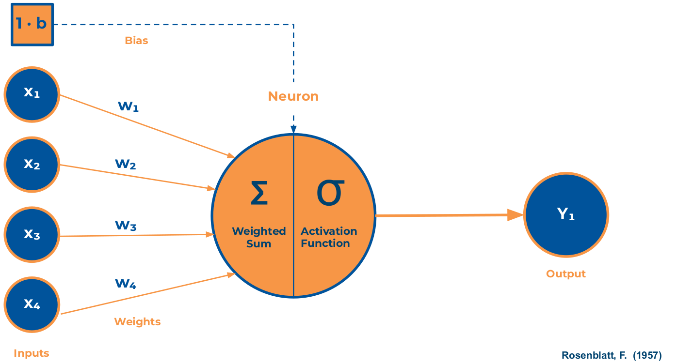

In this part of the course we take for granted that the definition of Machine Learning and its main real-world applications and the landscape of most frequently used algorithms are already known. We will focus on Deep Learning by applying Artificial Neural Networks.

And these are this week's objectives:

* What is Deep Learning?
* The Neuron and perceptron
* Gradient Descent
* Activation functions
* Backpropagation
* Normalization, Loss Function, Learning rate, Transfer Learning
* Basic Hard Model

As a guide for this week, we have left a series of videos to understand what neural networks are and are not, and what are their most basic concepts.

**Neural Networks:**

[***Supporting Code***](https://github.com/stephencwelch/Neural-Networks-Demystified)*to follow the videos*

<https://youtu.be/bxe2T-V8XRs>

<https://youtu.be/UJwK6jAStmg>

<https://youtu.be/5u0jaA3qAGk>

<https://youtu.be/GlcnxUlrtek>

<https://youtu.be/pHMzNW8Agq4>

<https://youtu.be/9KM9Td6RVgQ>

<https://youtu.be/S4ZUwgesjS8>

**Hard:**

On the other hand, we encourage you to build your first neural network in Keras, and to learn how to solve the MNIST dataset problem with DL

* [Create your first neural network from 0](https://www.aprendemachinelearning.com/crear-una-red-neuronal-en-python-desde-cero/)
* Introduction to Keras <https://medium.com/neuron4/introducci%C3%B3n-al-deep-learning-con-keras-b51c47560565>
* <https://nbviewer.jupyter.org/github/Yorko/mlcourse.ai/blob/master/jupyter_english/tutorials/Keras_easy_way_to_construct_the_Neural_Networks_fixed.ipynb>

**Further Reading:**

Highly recommended reading

* <https://medium.com/free-code-camp/want-to-know-how-deep-learning-works-heres-a-quick-guide-for-everyone-1aedeca88076>

## #5 Challenge!

Tutorial Support <https://elitedatascience.com/keras-tutorial-deep-learning-in-python>

Step-by-Step first Keras model <https://machinelearningmastery.com/tutorial-first-neural-network-python-keras/>

Advanced <https://blogs.oracle.com/meena/simple-neural-network-model-using-keras-and-grid-search-hyperparameterstuning>

**RESOURCES**

[AISaturdays\_ChallengeSession5 .ipynb](https://app.eduflow.com/activities/ee6a1af7-d524-4772-a4c2-3ee9afa46b66/resources/8a4b05b2-bd9c-405b-99e5-6295aef79423" \t "_blank)

[mitbih\_train.csv](https://app.eduflow.com/activities/ee6a1af7-d524-4772-a4c2-3ee9afa46b66/resources/928970a8-4fab-4303-8cc3-96d8d7953f83" \t "_blank)

[AISaturdays\_ChallengeSession5\_solution.ipynb](https://app.eduflow.com/activities/ee6a1af7-d524-4772-a4c2-3ee9afa46b66/resources/0cc221f4-8c62-4e2c-918f-c89eb9519434" \t "_blank)